VRF Lab

Joshua Widjaja

Period 0-2 CCNP

Mr. Mason

**Purpose:**

The main purpose of this lab was to teach us how to configure network segmentation via Virtual Routing and Forwarding (VRF). We were introduced to and learned how to use Graphical Network Simulator-3 (GNS3). We developed skills in using GNS3 to route between two independent networks running simultaneously on the same routers. Lastly, we were exposed to the concepts of network segmentation and virtual network emulation.

**Background Information on Lab Concepts:**

|  |  |
| --- | --- |
| **Concepts** | **Information** |
| **Network Segmentation** | This is a concept and best practice used to divide a network into smaller pieces. Network segmentation enhances the organization of traffic management as well as network performance, security, and fault tolerance by lowering the dependence that each part of the network has on each other. |
| **Virtual Routing and Forwarding (VRF)** | VRF is a technology that allows a router to maintain multiple routing tables. Every VRF instance acts as though it is a separate router with its own forwarding table and routing decisions. This is done when the router using VRF splits into multiple routers. The separate networks can use the same IP addresses and ranges without overlapping IP addresses because they are entirely independent from one another. VRF allows for network segmentation due to its flexibility and efficient use of resources. |

**Lab Summary:**

Using GNS3, we were tasked to first set up a topology with 4 routers and 4 PCs, with two completely independent networks running at the same time on the same routers. We used 4 Cisco 7200 routers which had 4 ethernet ports each as well as 4 PCs. We created 2 VRF instances in our network with 2 PCs and 2 connected ports from each router. The routing protocol that we used for connectivity between VRFs was OSPF (Open Shortest Path First). We configured the two VRFs to be separate from one another but configured them with the same IP addresses. What we made different were the OSPF process IDs.

**Lab Commands:**

* Router(config)# **ip vrf [VRF_NAME]**
  + This command creates a VRF instance and gives it a name. After entering this command, you will enter VRF configuration mode
* Router(config-if)# **ip vrf forwarding [VRF_NAME]**
  + Once you are in VRF interface configuration mode from the previous command, this command associat4es an interface with a specific VRF instance on a router.
* Router(config)# **router ospf [process-id] vrf [VRF_NAME]**
  + In global configuration mode, this command enables OSPF routing in a VRF network and associates the OSPF process ID with a VRF instance
* Router# **show ip route vrf [VRF_NAME]**
  + In privileged mode, this command displaces the current state of the routing table for a specific VRF instance

**Network Diagram with IP’s:**

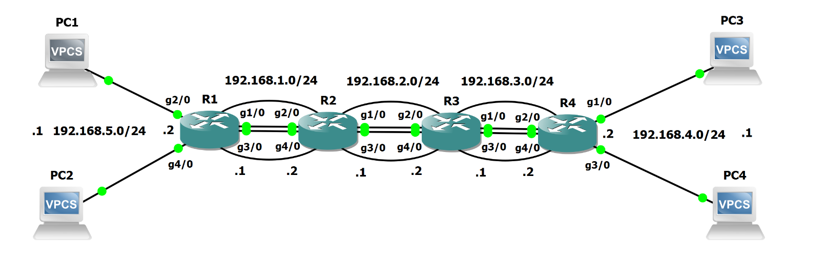

**Configurations:**

**R1 Configuration:**

Current configuration : 1571 bytes

upgrade fpd auto

version 15.2

service timestamps debug datetime msec

service timestamps log datetime msec

no service password-encryption

hostname R1

boot-start-marker

boot-end-marker

no aaa new-model

no ip icmp rate-limit unreachable

ip vrf COMP1

ip vrf COMP2

no ip domain lookup

ip cef

no ipv6 cef

multilink bundle-name authenticated

redundancy

ip tcp synwait-time 5

interface FastEthernet0/0

no ip address

shutdown

duplex half

interface GigabitEthernet1/0

ip vrf forwarding COMP1

ip address 192.168.1.1 255.255.255.0

negotiation auto

interface GigabitEthernet2/0

ip vrf forwarding COMP1

ip address 192.168.5.2 255.255.255.0

negotiation auto

interface GigabitEthernet3/0

ip vrf forwarding COMP2

ip address 192.168.1.1 255.255.255.0

negotiation auto

interface GigabitEthernet4/0

ip vrf forwarding COMP2

ip address 192.168.5.2 255.255.255.0

negotiation auto

router ospf 1 vrf COMP1

network 192.168.1.0 0.0.0.255 area 0

network 192.168.5.0 0.0.0.255 area 0

router ospf 2 vrf COMP2

router-id 1.1.1.1

network 192.168.1.0 0.0.0.255 area 0

network 192.168.5.0 0.0.0.255 area 0

ip forward-protocol nd

no ip http server

no ip http secure-server

no cdp log mismatch duplex

control-plane

mgcp profile default

gatekeeper

shutdown

line con 0

exec-timeout 0 0

privilege level 15

logging synchronous

stopbits 1

line aux 0

exec-timeout 0 0

privilege level 15

logging synchronous

stopbits 1

line vty 0 4

login

transport input all

end

**R2 Configuration:**

Current configuration : 1552 bytes

upgrade fpd auto

version 15.2

service timestamps debug datetime msec

service timestamps log datetime msec

no service password-encryption

hostname R2

boot-start-marker

boot-end-marker

no aaa new-model

no ip icmp rate-limit unreachable

ip vrf COMP1

ip vrf COMP2

no ip domain lookup

ip cef

no ipv6 cef

multilink bundle-name authenticated

redundancy

ip tcp synwait-time 5

interface FastEthernet0/0

no ip address

shutdown

duplex half

interface GigabitEthernet1/0

ip vrf forwarding COMP1

ip address 192.168.2.1 255.255.255.0

negotiation auto

interface GigabitEthernet2/0

ip vrf forwarding COMP1

ip address 192.168.1.2 255.255.255.0

negotiation auto

interface GigabitEthernet3/0

ip vrf forwarding COMP2

ip address 192.168.2.1 255.255.255.0

negotiation auto

interface GigabitEthernet4/0

ip vrf forwarding COMP2

ip address 192.168.1.2 255.255.255.0

negotiation auto

router ospf 1 vrf COMP1

network 192.168.1.0 0.0.0.255 area 0

network 192.168.2.0 0.0.0.255 area 0

router ospf 2 vrf COMP2

network 192.168.1.0 0.0.0.255 area 0

network 192.168.2.0 0.0.0.255 area 0

ip forward-protocol nd

no ip http server

no ip http secure-server

no cdp log mismatch duplex

control-plane

mgcp profile default

gatekeeper

shutdown

line con 0

exec-timeout 0 0

privilege level 15

logging synchronous

stopbits 1

line aux 0

exec-timeout 0 0

privilege level 15

logging synchronous

stopbits 1

line vty 0 4

login

transport input all

end

**R3 Configuration:**

Current configuration : 1552 bytes

upgrade fpd auto

version 15.2

service timestamps debug datetime msec

service timestamps log datetime msec

no service password-encryption

hostname R3

boot-start-marker

boot-end-marker

no aaa new-model

no ip icmp rate-limit unreachable

ip vrf COMP1

ip vrf COMP2

no ip domain lookup

ip cef

no ipv6 cef

multilink bundle-name authenticated

redundancy

ip tcp synwait-time 5

interface FastEthernet0/0

no ip address

shutdown

duplex half

interface GigabitEthernet1/0

ip vrf forwarding COMP1

ip address 192.168.3.1 255.255.255.0

negotiation auto

interface GigabitEthernet2/0

ip vrf forwarding COMP1

ip address 192.168.2.2 255.255.255.0

negotiation auto

interface GigabitEthernet3/0

ip vrf forwarding COMP2

ip address 192.168.3.1 255.255.255.0

negotiation auto

interface GigabitEthernet4/0

ip vrf forwarding COMP2

ip address 192.168.2.2 255.255.255.0

negotiation auto

router ospf 1 vrf COMP1

network 192.168.2.0 0.0.0.255 area 0

network 192.168.3.0 0.0.0.255 area 0

router ospf 2 vrf COMP2

network 192.168.2.0 0.0.0.255 area 0

network 192.168.3.0 0.0.0.255 area 0

ip forward-protocol nd

no ip http server

no ip http secure-server

no cdp log mismatch duplex

control-plane

mgcp profile default

gatekeeper

shutdown

line con 0

exec-timeout 0 0

privilege level 15

logging synchronous

stopbits 1

line aux 0

exec-timeout 0 0

privilege level 15

logging synchronous

stopbits 1

line vty 0 4

login

transport input all

end

**R4 Configuration:**

Current configuration : 1552 bytes

upgrade fpd auto

version 15.2

service timestamps debug datetime msec

service timestamps log datetime msec

no service password-encryption

hostname R4

boot-start-marker

boot-end-marker

no aaa new-model

no ip icmp rate-limit unreachable

ip vrf COMP1

ip vrf COMP2

no ip domain lookup

ip cef

no ipv6 cef

multilink bundle-name authenticated

redundancy

ip tcp synwait-time 5

interface FastEthernet0/0

no ip address

shutdown

duplex half

interface GigabitEthernet1/0

ip vrf forwarding COMP1

ip address 192.168.4.2 255.255.255.0

negotiation auto

interface GigabitEthernet2/0

ip vrf forwarding COMP1

ip address 192.168.3.2 255.255.255.0

negotiation auto

interface GigabitEthernet3/0

ip vrf forwarding COMP2

ip address 192.168.4.2 255.255.255.0

negotiation auto

interface GigabitEthernet4/0

ip vrf forwarding COMP2

ip address 192.168.3.2 255.255.255.0

negotiation auto

router ospf 1 vrf COMP1

network 192.168.3.0 0.0.0.255 area 0

network 192.168.4.0 0.0.0.255 area 0

router ospf 2 vrf COMP2

network 192.168.3.0 0.0.0.255 area 0

network 192.168.4.0 0.0.0.255 area 0

ip forward-protocol nd

no ip http server

no ip http secure-server

no cdp log mismatch duplex

control-plane

mgcp profile default

gatekeeper

shutdown

line con 0

exec-timeout 0 0

privilege level 15

logging synchronous

stopbits 1

line aux 0

exec-timeout 0 0

privilege level 15

logging synchronous

stopbits 1

line vty 0 4

login

transport input all

end

**R1 IP Routes:**

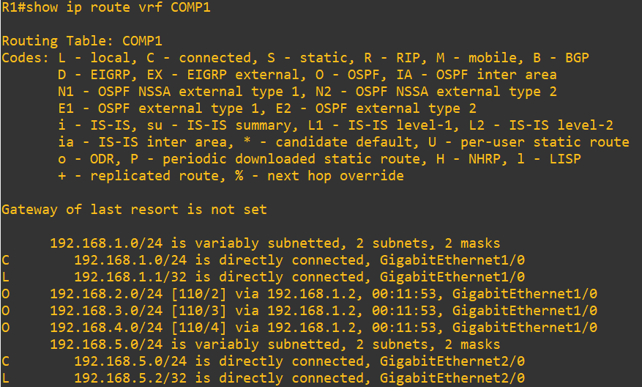

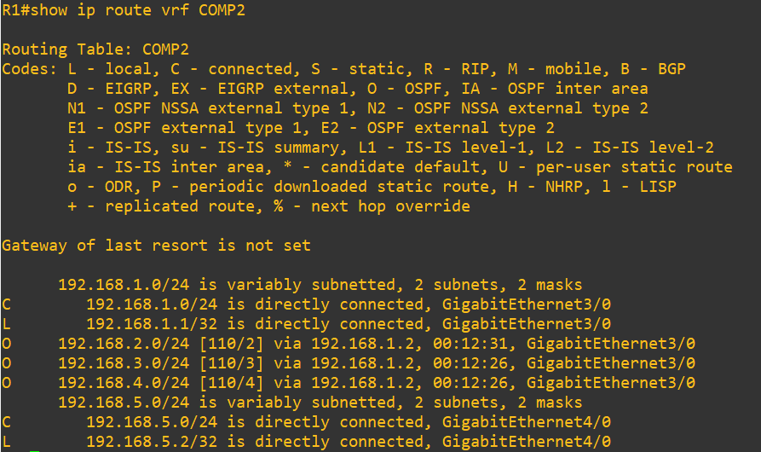

**R2 IP Routes:**

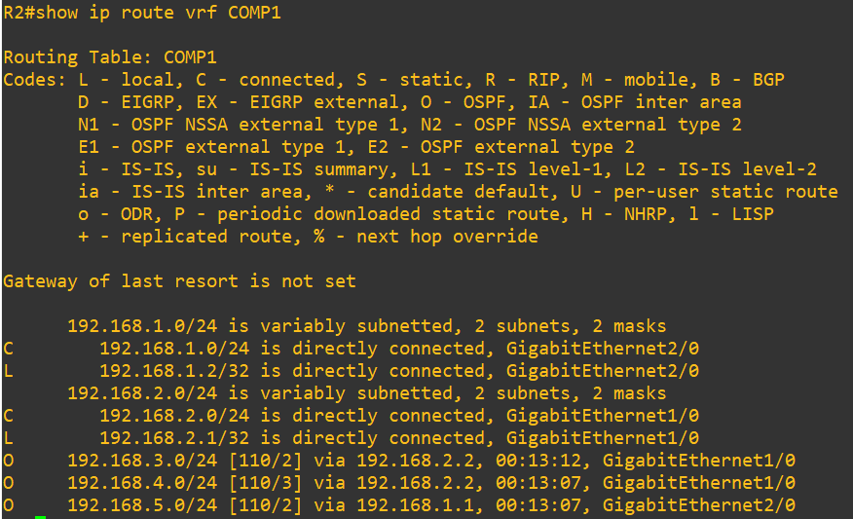

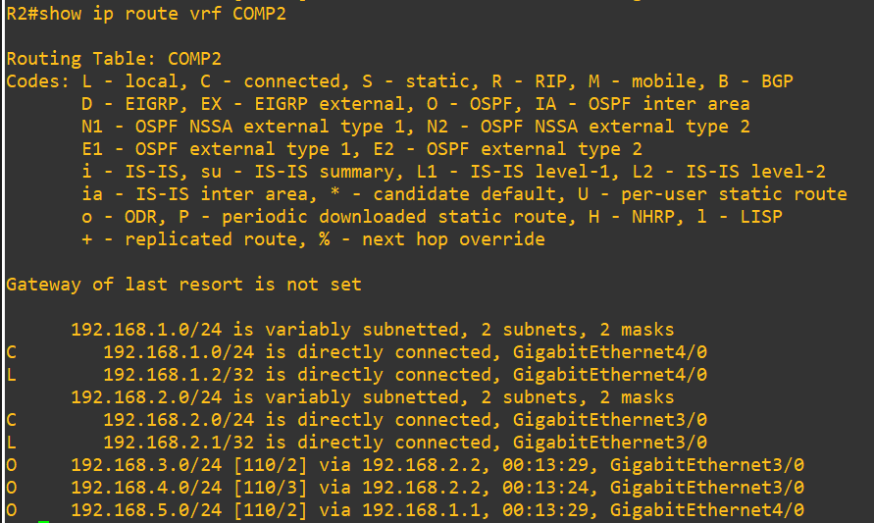

**R3 IP Routes:**

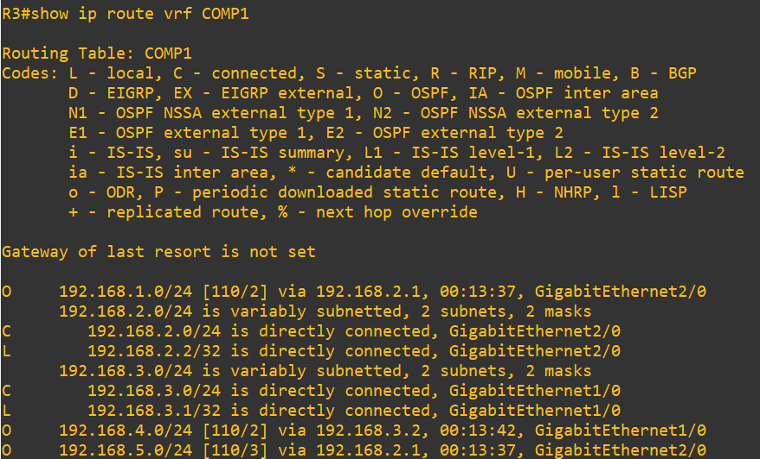

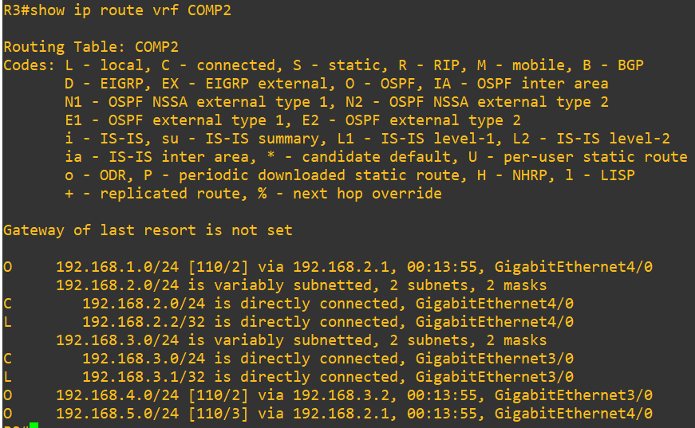

**R4 IP Routes:**

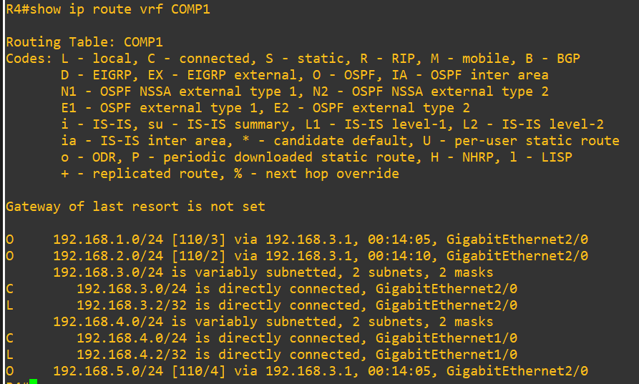

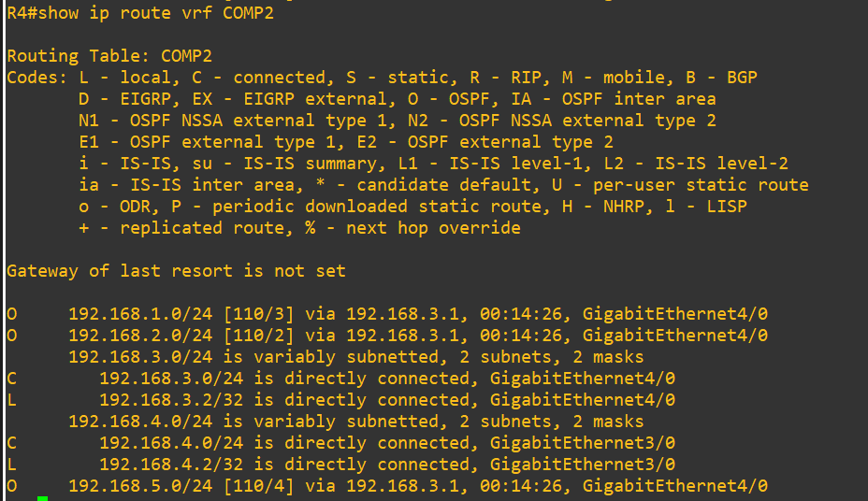

**Ping from PC1 to PC3:**

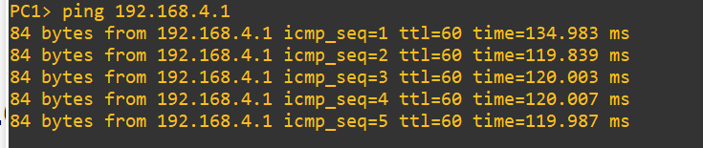

**Ping from PC2 to PC4:**

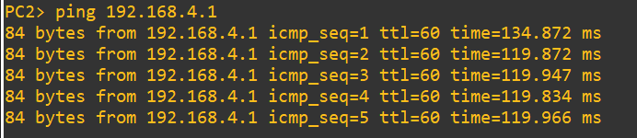

**Ping from PC3 to PC1:**

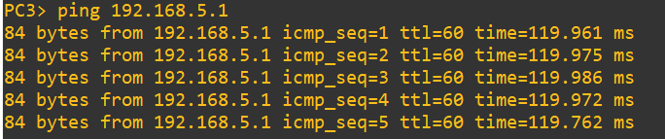

**Ping from PC4 to PC2:**

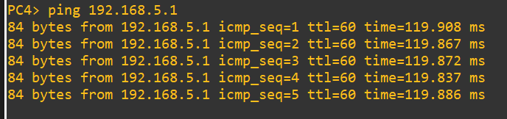

**Problems:**

We first had correctly established OSPF for a specific VRF instance in COMP1 after confirming for connectivity between the two PCs and OSPF routes in our routing tables. When inputting the same commands for a specific VRF instance in COMP2, we weren’t able to ping across our two PCs. We verified with our routing tables to see what was wrong and found that we didn’t have any OSPF routes in the COMP2 routing tables. We found no issues even after cross examining our COMP2 commands with COMP1’s commands. After doing a bit more research, we deduced that our OSPF router IDs may have been causing the OSPF routes to not be up on our routing tables. We checked by entering a show ip ospf command and found that a router had no router ID for OSPF in COMP2. We checked COMP1 once again and saw that it had an OSPF process ID of 1, whereas COMP2 had an OSPF process ID of 2. Although we had prior knowledge that OSPF router IDs were automatically set up, we found that using the same addresses caused the automatically configured router IDs to be the exact same for both OSPF process IDs, ultimately causing our problem of there being no OSPF routes on COMP2. We now knew that the one thing that we had to make different on the different routers was the OSPF process ID. We then manually configured an OSPF router ID on COMP2 for R1 and were able to fix our problem. Our OSPF routes were up and working and we were able to get connectivity with pings across both PCs.

**Conclusion:**

In conclusion, this lab was completed quickly with minimal errors other than not getting OSPF routes do to not manually configuring Router IDs. We set up a simple network using network segmentation via VRFs in the Graphical Network Simulator 3 (GNS3). We were already equipped with skills in setting OSPF, so the main challenge was figuring out new VRF commands and using the GNS3 software. All in all, we were able to acquire new skills in working with VRF, using OSPF in conjunction with VRF, and the concept of network segmentation in GNS3 software.

**Teacher Signoff Page:**

